Quick E-Commerce Delivery Performance & Customer Satisfaction Report
Project Type: End-to-End Data Analytics
Tools Used: Python (Pandas), MySQL, Power BI
Data Scope: 99,000+ Orders | Blinkit, JioMart, Swiggy Instamart

1. Executive Summary
Objective
To develop an interactive Power BI dashboard providing key insights into e-commerce delivery performance, customer satisfaction, and service quality. This project encompasses the full data lifecycle: cleaning, exploratory analysis, relational modeling, and visualization.
Key Findings
- Market Scale: Total order volume reached 99K with a Gross Merchandise Value (GMV) of 53M INR. Market share is evenly split between Blinkit (31.4%), JioMart (31.7%), and Swiggy Instamart (31.7%).
- Product Performance: Grocery is the dominant category (13M INR), followed by Personal Care (11M INR).
- Service Benchmarks: The average service rating is 3.22/5.0, with a remarkably low refund rate of 0.46%.
- Critical Pain Points: Delivery delays (40+ mins) correlate directly with low ratings. Primary complaints include "Wrong item delivered" and "Missing items," totaling over 14,000 instances.
- Platform Variance: Swiggy Instamart exhibits the highest refund rate (0.50%), indicating a need for localized operational improvements.

2. Introduction
Project Context
As the "Quick Commerce" sector in India grows, maintaining a balance between speed and quality is vital. This project analyzes delivery data for major hyperlocal players to identify operational bottlenecks and improve customer retention.

Problem Statement
The business lacked a centralized view of performance across multiple platforms. Fragmented data made it difficult to track KPIs, understand the root causes of refunds, and correlate delivery speed with customer satisfaction.

3. Data Methodology
3.1 Data Acquisition
- Source: messy_ecommerce_delivery_data.csv
- Initial State: ~101,000 records across 11 columns. The raw data contained missing values, inconsistent platform naming, and duplicate entries.
3.2 Data Cleaning & Transformation (Python/Pandas)
Using a Jupyter Notebook environment, the following ETL steps were performed:
- Standardization: Converted Order Date to a uniform datetime format and handled mixed-case strings in the Platform column.
- Imputation: Missing numeric values in Order Value and Delivery Time were filled using median values to mitigate the impact of outliers.
- Type Conversion: Coerced non-numeric entries into valid floats/integers and mapped Boolean logic (yes/no) to standardized "Yes/No" strings.
- Deduplication: Removed redundant records to ensure the accuracy of the 99K final order count.
3.3 Data Storage (MySQL)
The cleaned data was migrated to a MySQL relational database to allow for structured querying.
SQL
-- Schema Creation
CREATE DATABASE ecommerce_db;
USE ecommerce_db;

CREATE TABLE ecommerce (
order_id VARCHAR(50) PRIMARY KEY,
platform VARCHAR(50),
delivery_time_minutes FLOAT,
product_category VARCHAR(50),
order_value FLOAT,
customer_feedback TEXT,
service_rating INT,
delivery_delay VARCHAR(10),
refund_requested VARCHAR(10),
order_date DATE
);

4. Exploratory Data Analysis (EDA)
EDA was conducted using SQL to derive the logic for the final Power BI visuals. Key queries focused on:
- Rating Correlation: Identifying the average rating drop as delivery time exceeds the 30-minute window.
- Feedback Mining: Aggregating the most frequent phrases used in 1-star and 2-star reviews.
- Outlier Detection: Identifying deliveries exceeding 50 minutes and their impact on refund requests.

5. Dashboard Development (Power BI)
Data Modeling
- Connection: Live connection to MySQL via the Import method.
- Calculated Measures (DAX):
  - Total Order Value = SUM(ecommerce[order_value])
  - Refund Rate % = DIVIDE(CALCULATE(COUNT(order_id), refund_requested="Yes"), [Total Orders])
Visualizations

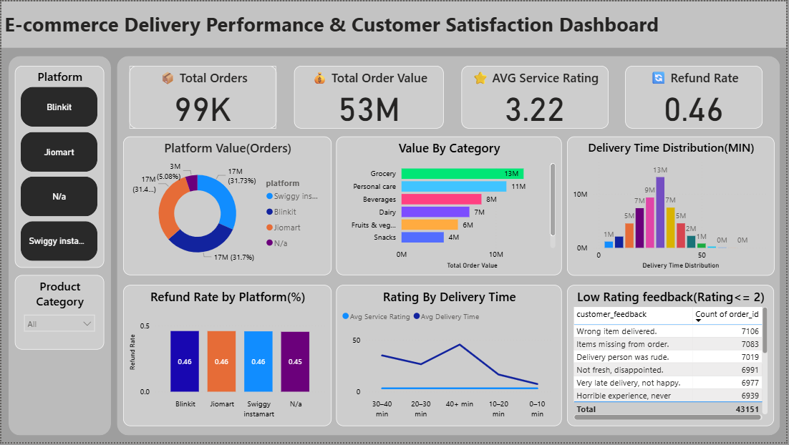

6. Strategic Recommendations
- Reduce Perishable Latency: Prioritize Fruits & Vegetables for "Fast Track" delivery to ensure freshness and boost ratings.
- Quality Control Overhaul: Focus on Swiggy Instamart’s fulfillment process to address the 0.50% refund rate, specifically targeting "Missing Items."
- Marketing Focus: The "Snacks" category is currently underperforming; targeted promotions could increase the Average Order Value (AOV).
- Logistics Optimization: Cap delivery windows at 30 minutes where possible, as satisfaction scores drop by nearly 40% once the 40-minute mark is hit.

7. Conclusion
This end-to-end pipeline transforms raw, fragmented retail data into actionable business intelligence. By integrating Python, SQL, and Power BI, the project provides a scalable framework for monitoring the health of Quick-Commerce operations.

